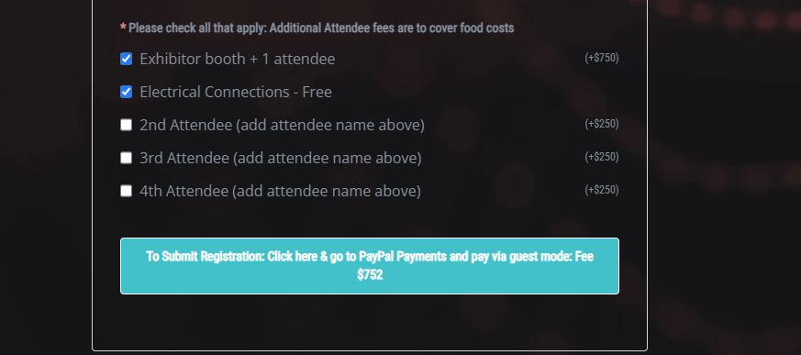



**Make choices**

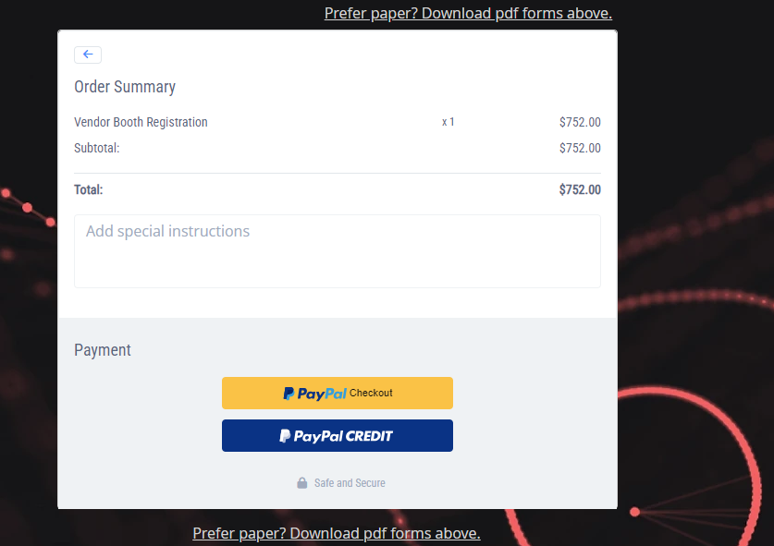



**If applicable**





